Own Order
Switch First
Service password-encryption
Ip domain-name cisco.com
Username CAdmin privilege 15 secret itsasecret
Crypto key generate rsa
1024
Ip ssh version 2
Ip ssh time-out 60
Ip ssh authentication-retries 2
line vty 0 4
login local
transport input ssh
line vty 5 15
login local
transport input ssh
Ip default-gateway
Vlan 15 -name servers - exit
Interface vlan 15 - Ip address 192.168.45.66 255.255.255.192
Vlan 30 - name PCs - exit
Interface vlan 30 - ip address 192.168.45.130 255.255.255.192
Vlan 45 - name Native - exit
Interface vlan 45 - ip address 192.168.45.18 255.255.255.240
Vlan 60 - name Management - exit
Interface vlan 60 - ip address 192.168.45.34 255.255.255.240
Interface range fa0/1 - 10 - switchport access vlan 30 - no shutdown
Interface range fa0/11-20 - switchport access vlan 15- no shutdown
Interface range fa0/1-20 switchport mode access
Interface g0/1 - switchport trunk native vlan 45 - switchport mode trunk - no shutdown
Interface fa0/1 - switchport mode access - switchport port-security - switchport port-security maximum 2 - switchport port-security mac-address sticky - switchport port-security violation restrict
Interface range fa0/21-24 - shutdown
Interface g0/2 shutdown
ip default-gateway 192.168.45.33

Router
Interface g0/0.15 - Encapsulation dot1Q 15 - Ip address 192.168.45.65 255.255.255.192 - ip nat inside
Interface g0/0.30 - Encapsulation dot1Q 30 - ip address 192.168.45.129 255.255.255.192- ip nat inside
Interface g0/0.45 - encapsulation dot1q 45 native - ip address 192.168.45.17 255.255.255.240- ip nat inside
Interface g0/0.60 - encapsulation dot1q 60 - ip address 192.168.45.33 255.255.255.240- ip nat inside
Interface g0/0 no shutdown
Ip dhcp pool LAN - network 192.168.45.128 255.255.255.192 - default-router 192.168.45.129
Router rip - Version 2 - network 192.168.45.0 - passive-interface g0/0 - passive-interface g0/0.15- passive-interface g0/0.30- passive-interface g0/0.45- passive-interface g0/0.60 - exit
ip route 0.0.0.0 0.0.0.0 Serial 0/1/0
Router rip - default-information originate
Access-list 1 permit 192.168.45.0 0.0.0.255
Ip nat inside source static 192.168.45.66 64.100.32.58
ip nat pool NATPAT 64.100.32.56 64.100.32.57 netmask 255.255.255.252
Interface s0/0/0 - ip nat inside - no shutdown
Interface s0/0/1 - ip nat inside - no shutdown
Interface s0/1/0 - ip nat outside- no shutdown

Go to pc and change ip configuration to dhcp

Subnet prefix | Addresses | Hosts | Netmask | Amouint of a class C
/ 30 | 4 | 2 | 255.255.255.252 | 1 / 64
/ 29 | 8 | 6 | 255.255.255.248 | 1 / 32
/ 28 | 16 | 14 | 255.255.255.240 | 1 / 16
/ 27 | 32 | 30 | 255.255.255.224 | 1 / 8
/ 26 | 64 | 62 | 255.255.255.192 | 1 / 4
/ 25 | 128 | 126 | 255.255.255.128 | 1 / 2
/ 24 | 256 | 254 | 255.255.255.0 | 1
/ 23 | 512 | 510 | 255.255.254.0 | 2
/ 22 | 1024 | 1022 | 255.255.252.0 | 4
/ 21 | 2048 | 2046 | 255.255.248.0 | 8
/ 20 | 4096 | 4094 | 255.255.240.0 | 16
/ 19 | 8192 | 8190 | 255.255.224.0 | 32
/ 18 | 16384 | 16382 | 255.255.192.0 | 64
/ 17 | 32768 | 32766 | 255.255.128.0 | 128
/ 16 | 65,536 | 65,534 | 255.255.0.0 | 256
/ 15 | 131,072 | 131,070 | 255.254.0.0 | 512
/ 14 | 262,144 | 262,142 | 255.252.0.0 | 1024
/ 13 | 524,288 | 524,286 | 255.248.0.0 | 2048
/ 12 | 1,048,576 | 1,048,574 | 255.240.0.0 | 4096
/ 11 | 2,097,152 | 2,097,150 | 255.224.0.0 | 8192
/ 10 | 4,194,304 | 4,194,302 | 255.192.0.0 | 16384
/ 9 | 8,388,608 | 8,388,606 | 255.128.0.0 | 32768
/ 8 | 16,777,216 | 16,777,214 | 255.0.0.0 | 65536

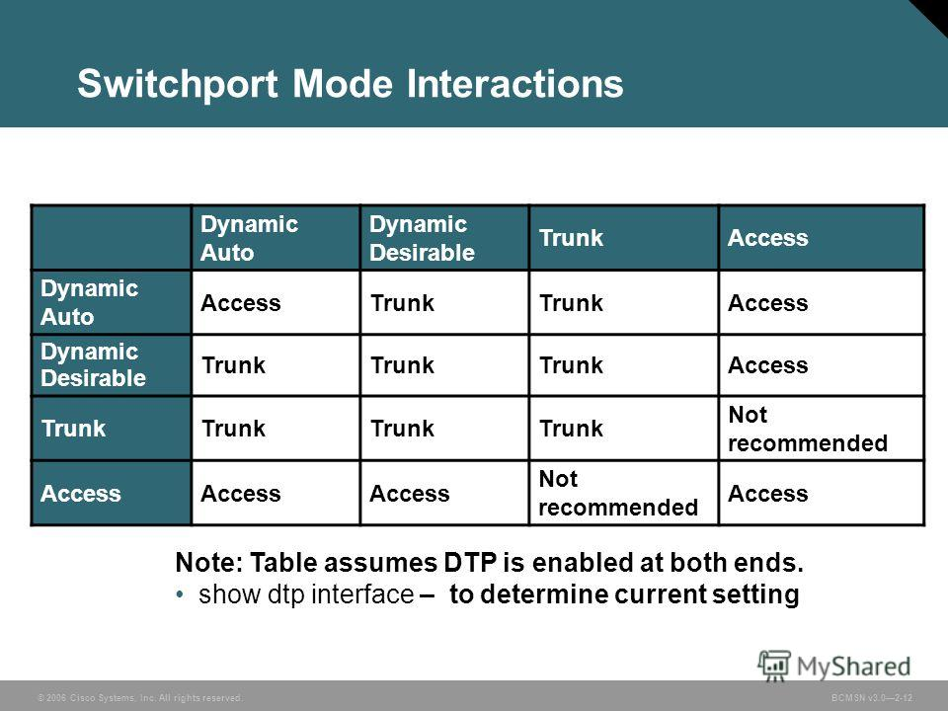

Assign hostname - Hostname s1
Password encryption - service password-encryption
Assign class as secret password for privileged EXEC mode access - enable secret class
Prevent unwanted DNS lookups - no ip domain-lookup
MOTD Banner - banner motd#enter text here and end with the character #
Create vlan - Vlan 99
Name a vlan - vlan x -name student
Config interface,also works with vlans - interface vlan99
Set ip address of interface - Ip address 192.168.1.2 255.255.255.0
Turn on or off interface - shutdown / No shutdown
Configure range of interfaces - interface range f0/1-24,g0/1-2
Assigns interfaces to access mode and to a vlan - Switchport access vlan 99
Assigns interface to trunking mode - switchport mode trunk
Assign default gateway - ip default-gateway 192.168.1.1
Console port with password - line con 0 - password cisco - login - logging synchronous
Vty allow telnet access - line vty 0 15 - password cisco - login
Clear mac address table of switch - clear mac address-table dynamic
Static mac address - mac address-table static 0050.56b3.6c89 vlan 99 interfacce fa0/6
Remove static mac address - no mac address0table static 0050.56b3.6c89 vlan 99 interfacce fa0/6
Save configuration - copy running-config startup-config

Setup ssh
Domain name server - ip domain-name CCNA-Lab.com
Create local database entry - username admin privilege 15 secret sshadmin
Make vty only allow ssh - line vty 0 15 - transport input ssh - login local
Generate crypto rsa crypto key - Crypto key generate rsa modulus
Modulus size-1024
Modify ssh config - ip ssh time-out 75 - ip ssh authentication-retries 2
Disable http service - no ip http server

Enable port security on a interface - switchport port-security
Static port security - switchport port-security mac-address xxxx.xxxx.xxxx
Remove static mac from port security -shutdown- no mac-address xxxx.xxxx.xxxx

Remove ip address from interface/vlan - No ip address
Setup trunking on interface - switchport mode dynamic desirable||switchport mode trunk

Sub interface (for Inter-VLAN routing in a router) - interface g0/1.1 - encapsulation dot1Q 1 - ip address 192.168.1.1 255.255.255.0 , interface g0/1.10 - encapsulation dot1q 10 - ip address 192.168.10.1 255.255.255.0 , interface g0/1 - no shutdown

DCE Connection clock rate - interface s0/0/0 - ip address 10.1.1.2 255.255.255.252 - clock rate 128000 - no shutdown

Recursive static route - Ip route network-address subnet mask ip-address
Directly connected static route - ip route network-address subnet-mask exit-interface
Default route - ip aroute 0.0.0.0 0.0.0.0 {ip-address or exit interface}
Remove static route - no ip route Ip route network-address subnet mask {ip-address or exit-interface}

Configre ripv2 routing - router rip - version 2- passive-interface {interface} - network 172.30.0.0
Disable auto aummarization-router rip - no auto-summary
Clear routing table - clear ip route *
Gateway of last resort - ip route 0.0.0.0 0.0.0.0 209.165.201.2
Advertise route to other routers - default-information originate

Create access list - access-list 1 deny 192.168.11.0 0.0.0.255 - access-list 1 permit any
Assign access list to interface - interface g0/0 - access-group 1 out
Create named access control list - ip access-list standard File_Server_restrictions - permit host 192.168.20.4 - deny any
Remove access list from interface - interface se0/0/0 - no ip access-group 11 out
Remove access-list completely - no access-list 11
Place acl on telnet/vty - line vty 0 15 - access-class 99 in

Http access and user credentials - ip http server username admin privilege 15 secret adminpass - ip http authentication local

DHCP exclude ip addresses from being leased - ip dhcp excluded-address 192.168.0.1 192.168.0.9
Setup pool of ips to be leased - ip dhcp pool R1G1 - network 192.168.0.1 255.255.255.0 - default-router 192.168.1.1 - dns-server 209.165.200.225 - domain-name ccna-lab.com - lease 2

Dhcp helper ( pass along dhcp requests) - interface g0/0 -ip helper-address 192.168.2.254

Configure static nat - ip nat inside source static 192.168.1.20 209.165.200.225
Specify interfaces as insode or outside - interface g0/1 - ip nat inside - interface s0/0/1 - ip nat outside

Clear Nat - clear ip nat translation * - clear ip nat statistics

Deine pool of usable public ip address - ip nat pool public_access 209.165.200.242 209.165.200.254 netmask 255.255.255.224

Define nat from inside source list to outside pool -ip nat inside source list 1 pool public_access

Nat overload setup - ip nat inside source list 1 pool public_access overload
Ip nat inside/outside depending on if its a inside address or outside address

Acl -
access-list 1 deny 192.168.11.0 0.0.0.255
access-list 1 permit any
interface GigabitEthernet0/0-ip access-group 1 out

Acl for vty
line vty 0 15
Access-class 99 in
Assignment Brief points of notice
Two sets of pcs both connect to seperate switches(one for each)
Single connection between both of the switches
One switch connects to router1
Router 1 connects to server room network(whichb contains web server)
Router 1 connects to internet via serial link

Requirements
Web server accessible from inside and outside hte network
Subnetworks:
Centers network used by three groups of users: - staff,sports,press. Each pc is allocated to one particular group and has an ip address from the range associated with that groups network

ISP - isp router already configured using legacy routing protocol
Isp provides two public ip address, one for web server and one for router interface which connects to isp router(use nat overload)

“Press” network address allocation
Currently there are 3 pcs(one for each group) but soon more “press” pcs will be installed on network. Must be possible for press pcs to be added quickly and simple at ehter work area as demand increases. New press pcs must require little or no network configuration, not acceptable for journalists to have to manually set ip addresses on their pcs

Security only encrypted passwords permitted in device configurations. Switches are to be protected to limit network they can be administered from. Must not bne permited for users to unpluig either hte staff1 or sports 1 pcs and replace with any other device. Any ad hoc devices can only be plugged into press network ports.

Dhcp on swith
Configure DHCPv4
S1(config)# ip dhcp excluded-address 192.168.1.1 192.168.1.10
S1(config)# ip dhcp pool DHCP1
S1(dhcp-config)# network 192.168.1.0 255.255.255.0
S1(dhcp-config)# default-router 192.168.1.1
S1(dhcp-config)# dns-server 192.168.1.9
S1(dhcp-config)# lease 3
Configure DHCPv4 for Multiple VLANs
S1(config)# interface f0/6
S1(config-if)# switchport access vlan 2
S1(config)# ip dhcp excluded-address 192.168.2.1 192.168.2.10
S1(config)# ip dhcp pool DHCP2
S1(dhcp-config)# network 192.168.2.0 255.255.255.0
S1(dhcp-config)# default-router 192.168.2.1
S1(dhcp-config)# dns-server 192.168.2.9
S1(dhcp-config)# lease 3
Enable IP Routing
S1(config)# ip routing
S1(config)# ip route 0.0.0.0 0.0.0.0 192.168.1.10
R1(config)# ip route 192.168.2.0 255.255.255.0 g0/1

Router dhcp commands
Router R1
R1(config)# interface g0/0
R1(config-if)# ip helper-address 192.168.2.254 R1(config-if)# exit
R1(config-if)# interface g0/1
R1(config-if)# ip helper-address 192.168.2.254
R2(config)# ip dhcp excluded-address 192.168.0.1 192.168.0.9
R2(config)# ip dhcp excluded-address 192.168.1.1 192.168.1.9
R2(config)# ip dhcp pool R1G1
R2(dhcp-config)# network 192.168.1.0 255.255.255.0
R2(dhcp-config)# default-router 192.168.1.1
R2(dhcp-config)# dns-server 209.165.200.225
R2(dhcp-config)# domain-name ccna-lab.com
R2(dhcp-config)# lease 2
R2(dhcp-config)# exit
R2(config)# ip dhcp pool R1G0
R2(dhcp-config)# network 192.168.0.0 255.255.255.0
R2(dhcp-config)# default-router 192.168.0.1
R2(dhcp-config)# dns-server 209.165.200.225
R2(dhcp-config)# domain-name ccna-lab.com
R2(dhcp-config)# lease 2

Nat static and dynamic
//use this for server
Gateway(config)# ip nat inside source static 192.168.1.20 209.165.200.225
Issue the ip nat inside and ip nat outside commands to the interfaces. Gateway(config)# interface g0/1 Gateway(config-if)# ip nat inside Gateway(config-if)# interface s0/0/1 Gateway(config-if)# ip nat outside

Define pool of usable public ip addresses
gateway# ip nat pool public_access 209.165.200.242 209.165.200.254 netmask 255.255.255.224
access-list 1 permit 192.168.1.0 0.0.0.255
# ip nat pool public_access 209.165.200.225 209.165.200.230 netmask 255.255.255.248
ip nat inside source list 1 pool public_access overload

Assign interfaces like normal
Nat port overload
Define an access control list that matches the LAN private IP addresses.

Define nat form inside source list to outside pool
Gateway(config)# ip nat inside source list 1 pool public_access

Own notes
If you have to setup addresses yourself go through subnetting in this order:
Determine the number of subnets needed.,(find number of hosts required for each area (also remembered connections between routers count!, if theres a connection to two switches use a summary subnet and then vlan network from the switch)
Then Divide the xxx.xxx.xxx.xxx/xx network based on the number of hosts per subnet. Going from largest to smallest!(for example 172.31.103.0/24 , 172.31.103.1 255.255.255.224,172.31.103.33 255.255.255.224,172.31.103.65 255.255.255.240)

Web server will be required to have a static ip address on the nat setup
Whatever internal ip address must always be converted in the nat to the same public address(same practise) - Ip nat inside source static 192.168.45.66 64.100.32.58 ( change values to whatever we are given) setup rip to learn routing or (setup static route to the server which will probably be easier)

Setup DHCP services for press pcs
Ip dhcp pool LAN - network 192.168.45.128 255.255.255.192 - default-router 192.168.45.129

Setup ripv2

Setup dynamic Nat with overload
Make sure server is one public ip, use a one for one swap
The other ip must be overloaded using ports,

There will be address ranges and routing informatoin by the network planners, so setup subnets depending on what we are allowed, then use nat to convert all of those ips to public overloaded ips, each pc will be part of one of the three subnetworks(probably vlans? Might have to use the router subinterfaces to route between them) also might have to have the nat have a larger subnet mask than t he subinterfaces to cover them all to convert them to what they are supposed to be
Press network will have to be dchp so that the user doesnt have to set up ip addresses rather just turn on dhcp. With the wording it might theorically to be possible to statically allocate ip address for staff which will not be unplugged and then only dynamically add the ip addresses of the jornalists, which would also mean that the ports that are not used by staff should be default set to journalist vlan

Easy marks , add as many passwords as possible, encrypt it all of it with ssh, if there is a network configuration ip add ACL to all vty of all of the switches and routers to make them secure. Allow as many mac addresses at press network ports as required, limit as many as possible if possible

